Desktop Publishing
Microsoft Publisher 2010: Printing Multiple Documents

PRINT FUNCTION
- To print your documents in Microsoft Publisher go to File > Print
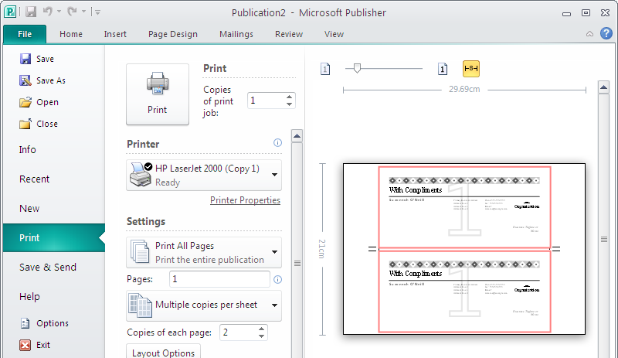
- In the Print Settings check ensure it is picking up the correct printer name:
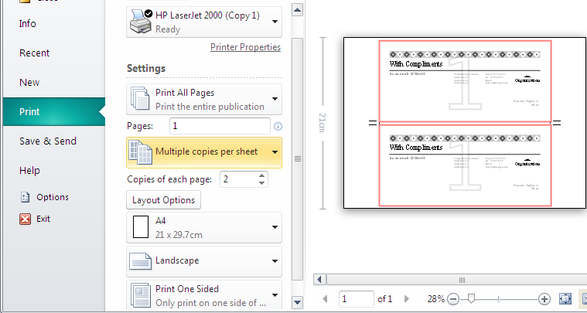
- Ensure correct orientation, paper size is correct.

- Check the Print Preview to ensure the layout of the document is as you require.
- If you are happy with the layout click Print the document.
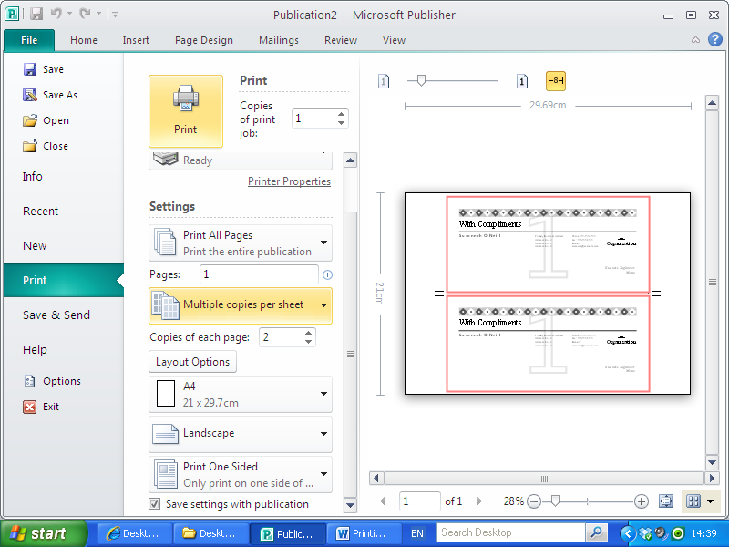

PRINTING MULTIPLE COPIES
When printing documents such as business cards and compliments slips, printing companies tend to print multiple copies on one sheet (this is a more cost effective approach as it means cost savings on paper and ink).
When using Microsoft Publisher you can set the printer to print multiple copies of the chosen document on one page.
- Go to File > Print
- Ensure that ‘Multiple copies per sheet’ is selected in the Printing Options box.
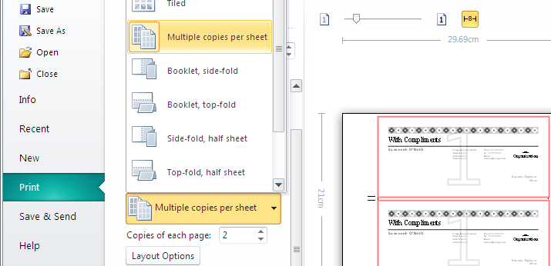

- Check the Print Preview to ensure the page is set to print multiple copies correctly.
- If you are happy with the layout click Print the document

PRINTING DOCUMENTS WITH CROP MARKS
When printing documents with multiple copies on one sheet it is appropriate to include ‘Crop Marks’. Crop marks provide a guide for a printing company to cut the documents with ease and precision.
When using Microsoft Publisher you can set the printer to print copies of documents showing the crop marks.
- Go to File > Print
- Ensure that ‘Multiple copies per sheet’ is selected
- Under the Printer Name options list , choose ‘Advanced Output Settings’
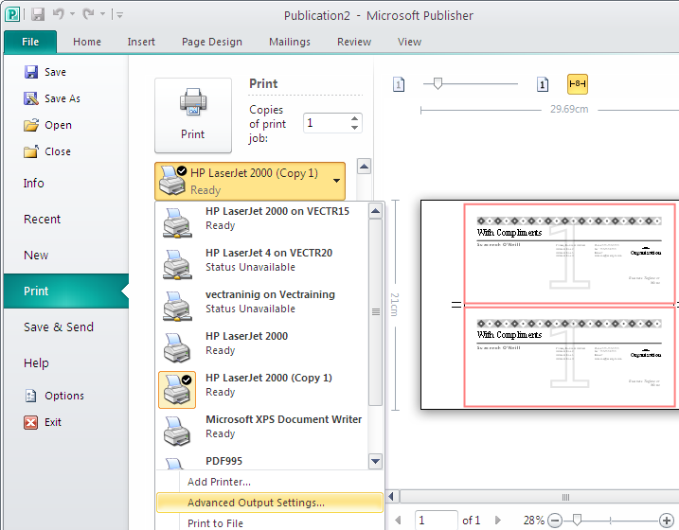
- Choose the ‘Marks and Bleeds’ Tab
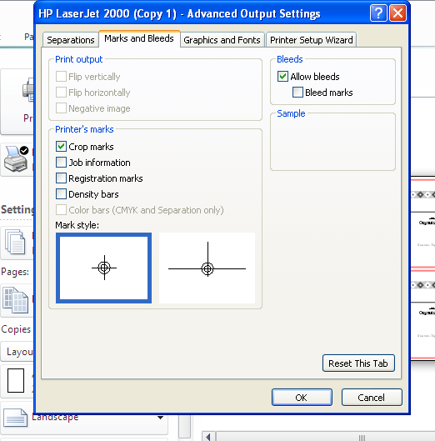
- Under the ‘Printer’s marks’ section and check the box ‘Crop marks’.
Click ‘OK’
- Check your Print Preview to ensure the page is set to print crop marks in the document.
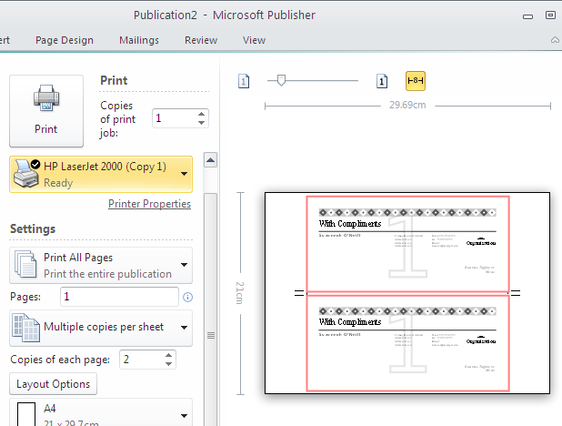
- Print the document

