Monaghan Institute
QQI 5N0785
Desktop Publishing 5N0785
Aim of the Programme Module: The purpose of this award is to equip the learner with the knowledge, skill and competence to produce a range of documents containing text and graphic images from design briefing to printing, using a Desktop Publishing (DTP) system.
Monaghan Institute
FETAC 5N0785

The learner will be enabled to create a range of possible designs to meet a given brief with due consideration for production cost, presentation format and environment, and print materials.

Create a range of designs to produce single documents, folded documents and multiple page documents.

To add folds to a document you have created select the Change Page Size button in the Format Publication window.
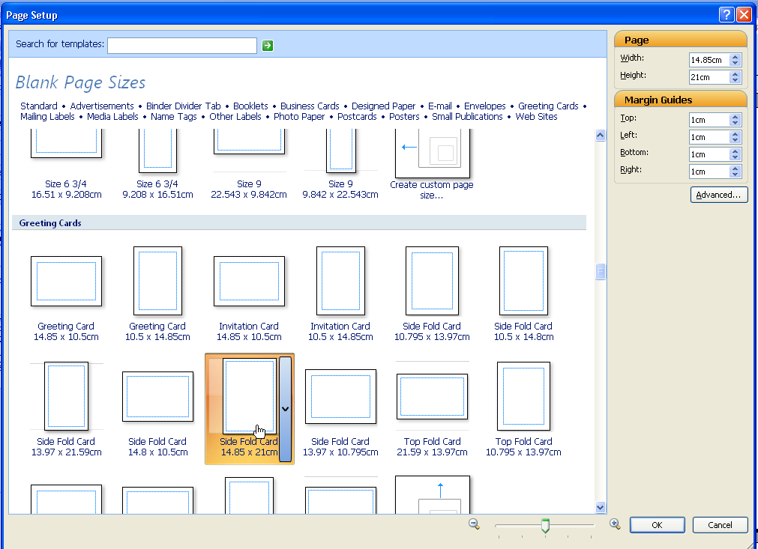
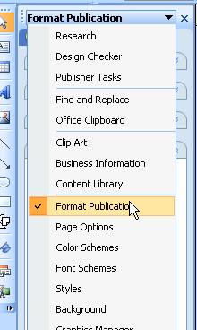
Browse down through the many available document types with the scroll bar and click on the required fold style. When you have chosen the style you require click on ok.
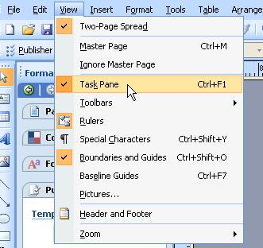

NOTE: If the Format Publication task pane is not showing click on View > Task Pane and turn it on. In addition if the Format Publication option is not turned on click on the drop down menu and select the correct option from the list.

Identify and compare the relative costs of different printing options e.g. photocopying, laser printing and commercial printing giving consideration to environment and print materials.

