Monaghan Institute
QQI 5N0785
Desktop Publishing 5N0785
Aim of the Programme Module: The purpose of this award is to equip the learner with the knowledge, skill and competence to produce a range of documents containing text and graphic images from design briefing to printing, using a Desktop Publishing (DTP) system.
Monaghan Institute
FETAC 5N0785

Learners will be able to set up a document for publication or printing specifying all required layout characteristics such as page, text, frame and table setup.

Setup different blank page sizes specifying layouts, orientation, margins, rows and columns and gutters.
Insert a new page
To insert a new page into a publisher document you are currently working on simply right click on the page at the bottom left corner of the application. From the menu which will appear Insert Page will appear at the top of the menu.
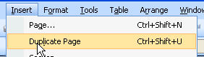
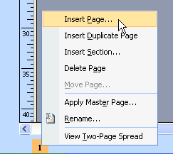
In addition this option can also be accessed from the Insert menu at the top of the application.

NOTE: A inserting a Duplicate Page will insert a copy of the page you are currently working on.
Change a page background
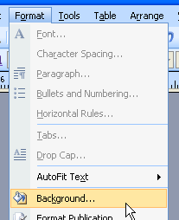
To change the background of a publisher document click on Format > Background, this will open the Background task pane to the left of the application.
The More Colours option will allow you to choose any colour you chose.
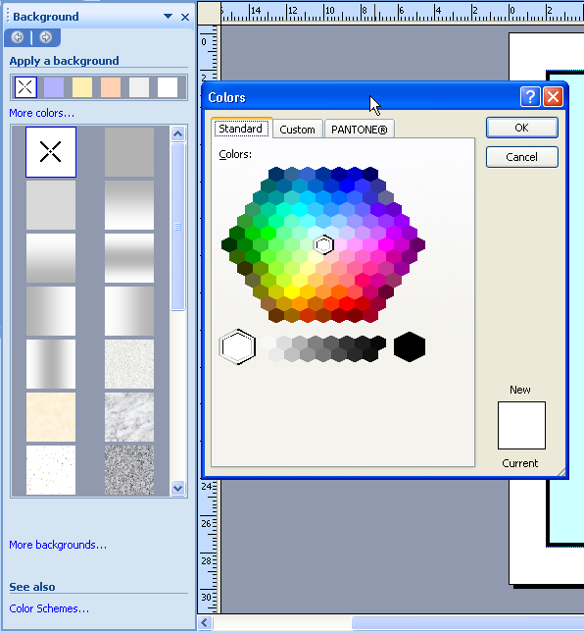

In addition you can choose one of the preset background present on the task pane and change the shading of this background.

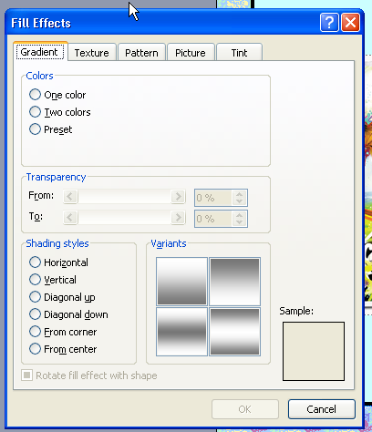

If the More Backgrounds option is selected you have the option to add more than one colour, preset options and shading styles. In addition on the Texture tab preset textures can be applied to the background of the document. The Picture tab will allow you to add any picture you have stored as a background.

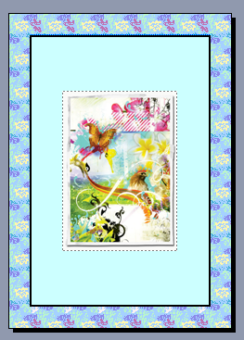

A background will fill the page of the document appearing on any uncovered white space.
NOTES:
Master page to maintain consistency
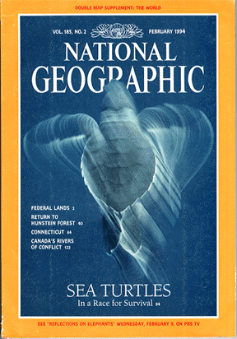
Master pages allow us to create consistency within group of pages or documents which we have created. The consistency refers to anything which remains the same from one publication to the next, for example the National Geographic always uses the same format for its front cover. A master page could be used to maintain this consistency.

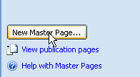
To create a master page go to View > Master Page. This will open the master view for the document you are working on. In this example I will create a cover for a magazine called MIFET Matters. The objects which do not change from one publication the next are the frame, the logo, the title and the college name in the footer.
To create a Master Page for a document first you must save the master page, to do this click on the New Master Page button at the bottom of the Edit Master Pages toolbar.
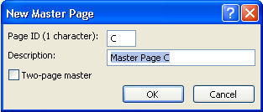

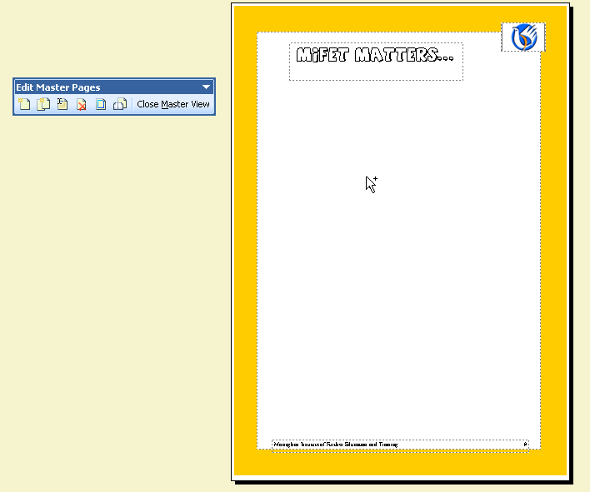
When you have saved the master page you can edit it to the design specifications you want.

When the master page is complete save the document, and close the Master View.
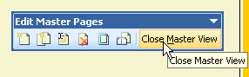

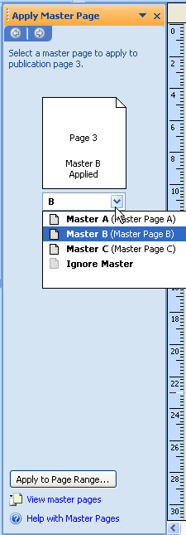
To use a Master Page go to Insert > Page and select the relevant master page as shown. Alternatively the master page can be applied after through the Master Page Task Pane to the left of the application.

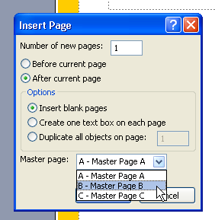

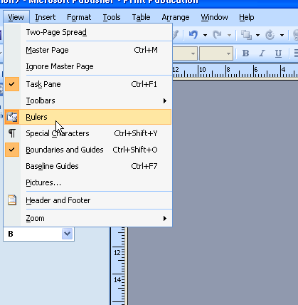
Set tab margins and indents on the ruler
To apply tabs first you must ensure your ruler is turned on. To do this go to View > Rulers.
This will turn on the ruler to the top and left of the publisher document you are working in.
Tabs are applied to text boxes. To view the tabs click into the textbox and the tabs will appear at the top of the screen. To move a tab click and hold then drag it to the left or to the right.
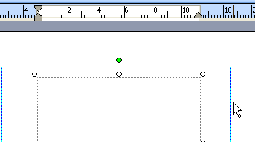

Different tab types have different names. The first tabs are the First Line Indent and the Left Indent these move together and apply to the formation of the paragraph.
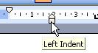
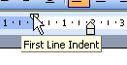

The First Line Indent shows the indent for the fist line of a paragraph and the Left Indent represents every line in the paragraph after the first line, as shown in the following example.
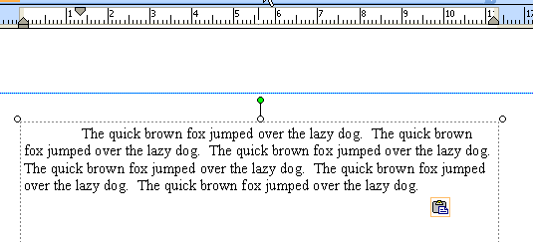

The other tabs are named as follows:

The left tab left aligns text connected to it, the right tab right aligns text, the center tab center aligns the text and the decimal tab lines up the decimal points (commonly used with currency).
NOTE: Once a tab is created it is applied from that point forward for the rest of a document.
Tab a paragraph that has already been typed
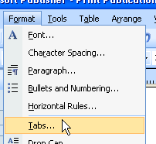
If you want to apply a tab to a paragraph that has already been created, highlight the paragraph and apply the required tab, this will not affect the whole document only the part of the document which has been highlighted.

Tabs can also be created using the exact position according to the ruler. To turn on the tabs window go to Format > Tabs or double click on the ruler on a tab which has already been created.
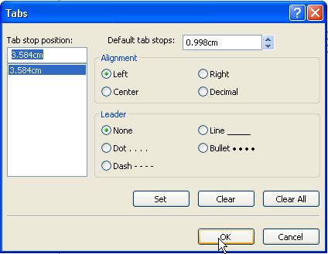
Type the exact position of the tab you wish to create from here you can also set the alignment of the text on the tabs. The leader dots of the tabs and tabs can also be deleted from this window.

Leader tabs are used as follows: to turn on leader dots select the tab position and click the leader style you want to use. Then click on Set.
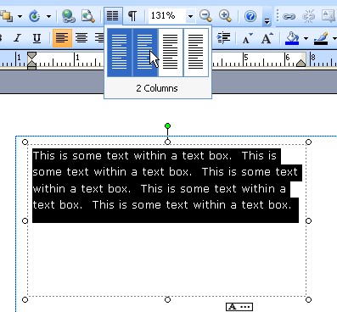
Columns are also applied in a similar format to other Microsoft packages. After you have added the text to your text box highlight all the text in the document. Go to the column symbol on the Formatting toolbar and click on the number of columns required.
The text within the text box will be changed into the required number of columns.

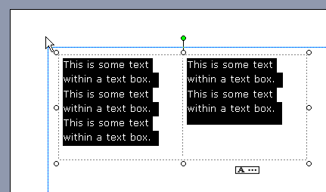
NOTES:

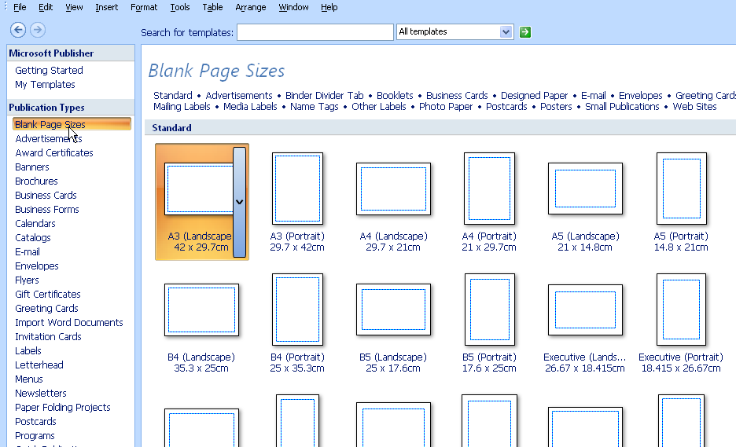
To create a new document click on File > New then select the paper size and orientation which you need to create your document. In this example I will create an A4 landscape poster.

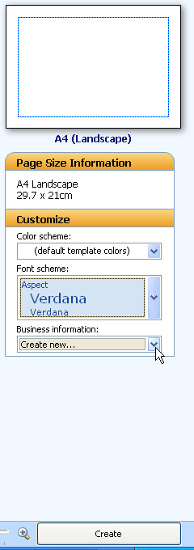

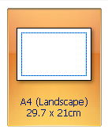
As with creating a default preset publication the Page Size Information and the Customise options can be edited to create d document of your choice.

When you have selected the required options click on the Create button and the document will be created for you.

This will create a blank document of the correct size, orientation and with the selected colour and font schemes.

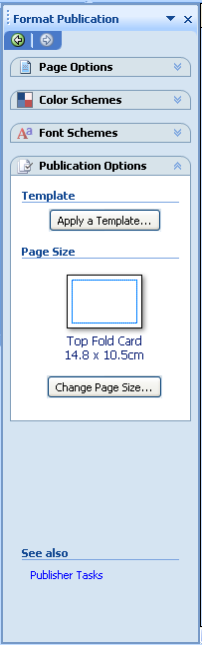
Margins/gutters are shown within a publisher document as a light blue dotted line around the edging of the page. These lines are not printed when the final document is printed; they are shown to give you the designer a guide as to your distance from the edge of the page.

To edit the Margin Guides of the document you have created click on the Change Page Size button to the left in the Format Publication task window. When the required guides have been selected click on the ok button.

Identify paper sizes with a reference to the ISO A-series i.e. A0, A1, A2, A3, A4 etc.

Employ basic typographic tools to specify features such as: fonts, sizes, styles colour, spacing between characters and between lines etc.

Use grids, rulers, margin guides and other system features for precision placement of text and graphics.

Add a text box, apply text alignment, tabs and columns

To add any text to a Publisher document you need to add text boxes to the document. Text boxes are available in the Object Toolbox which is usually available on the left side of the application.
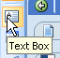
When you click on the text box button your curser will change to a black target plus symbol. Draw the size of text box you require, watching the rulers to the left and top of the document as a guide.

NOTE: If the rulers are not visible turn them on by select Veiw > Toolbars.

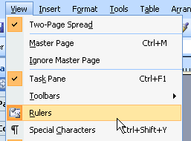

Formatting is applied in a text box as it is applied in the usual format within Microsoft Office. For example to apply text alignments highlight the text to be aligned and choose the required alignment. The following text is aligned to the centre of the text box.

For tabs the usual method of applying tabs is used. Click on the ruler to add the tab at the measurement you need, to apply the tab in the text box click on the tab button on the keyboard. To open the tabs window double click on any tab within the toolbar.
In the following example two tabs have been applied to the ruler. The first tab is a centred tab and the second tab is being change to a left alignment.
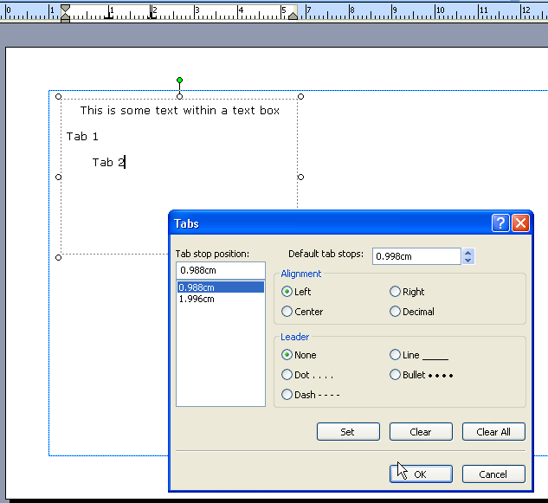
NOTE: Leader dots can be applied to a tab to allow ease of reading a menu for the end user. Left, right and center tabs can be added to keep a text boxes neat, decimal aligned tabs are used for number with decimal places such as prices on a menu.

Link text boxes
When you create a text box you specify the size of the text box as you drag the area of the text box. As text is added to the text box the text box may run out of white space or ‘room’.
Publisher will ask you if you wish to use autoflow as you run out of white space in the text box. It is best to select No with this option and to add your own text box u autoflow as shown in the following steps.
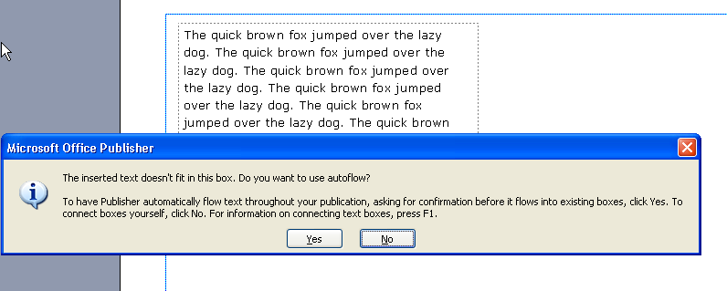
If the text box is full Publisher shows you this with the text in overflow symbol, which will appear at the bottom of the text box as shown.
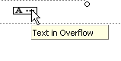
To view the missing text two options can be taken. The first is to click on the text box and increase the size of the box to allow more room for the text.
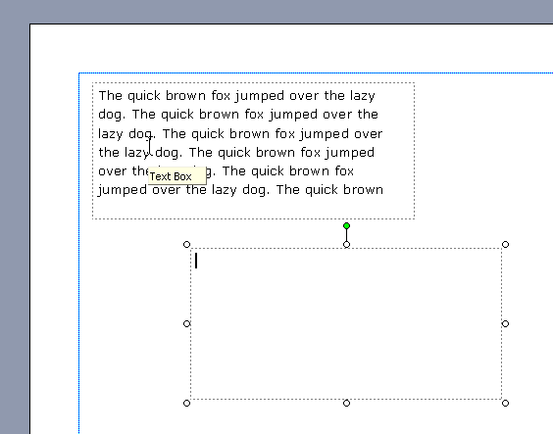

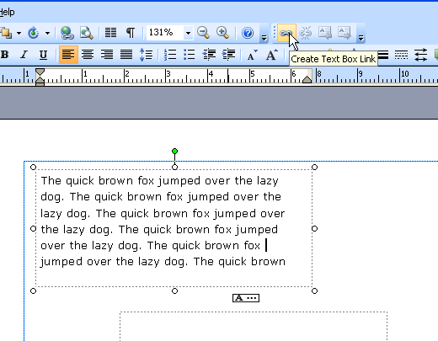
The second option is to create a second text box where it is required.

Click on the Create Text Box Link on the formatting toolbar as shown.
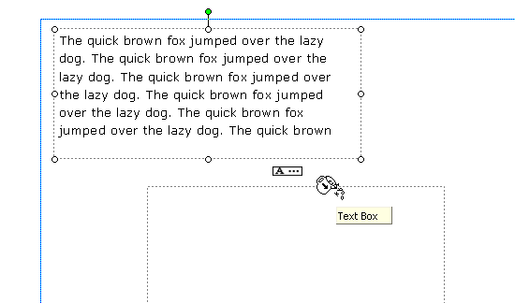
This will show the overflow jug which contains the extra letters!

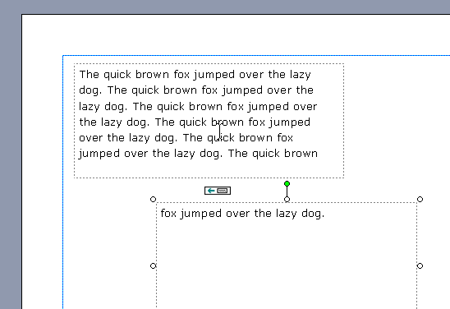
To join the two text boxes simply click on the second text box with the overflow jug symbol and the additional text will appear in the second text box.

Place text inside frames and control the white space between frame and text.
Add a header and footer apply automatic page numbering
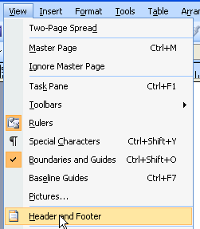
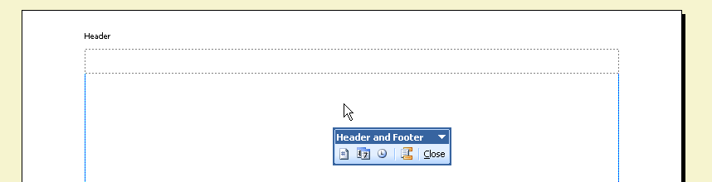
To add a header or footer to a publisher document click on View > Header and Footer this will open the header and footer option for the document automatically opening the header and footer toolbar.
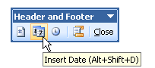

From this toolbar the page number and the date and time can be added to the document. In addition the page numbers and date and time can be added to the document from the Insert toolbar.
Add special characters or symbols

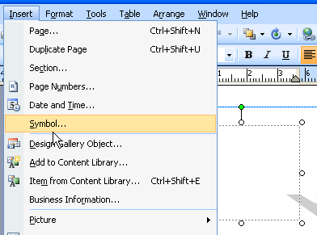
To add any special character or symbol to a publisher document a text box must first be inserted into the page. Click the cursor into the text box and go to Insert > Symbol.
NOTE: This option will not be available if you have not clicked into the text box first.

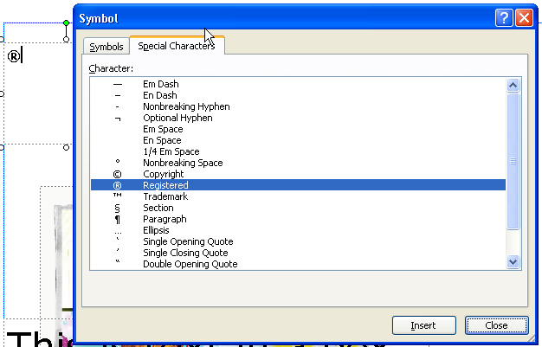
Click on the Symbol or Special Characters tab according to the object required. In this example I have added a registered character.
To add the character to the text box click on the character and then click on the insert button.

Add a border, lines, frames(boxes) adjusting thickness, shade and shading
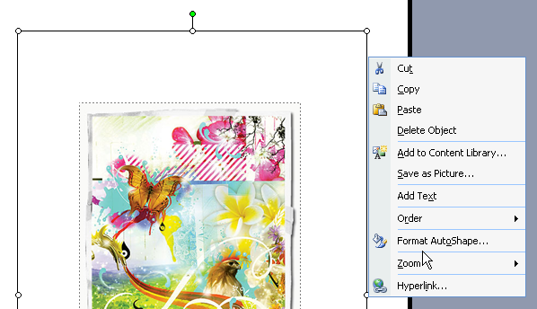
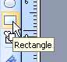
To add a border or frame to a document click on the rectangle button in the objects toolbar, draw the rectangle to the required size. Right click on the rectangle and click on Format AutoShape.

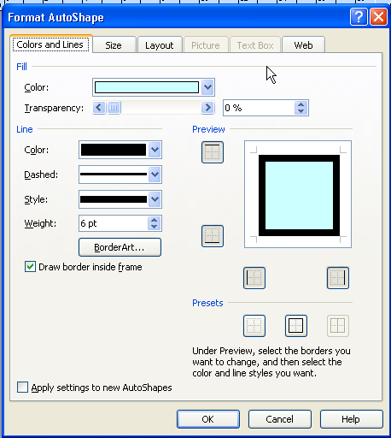
Format the rectangle to the required fill shading, line colour, style and weight. Apply the lines to the required margins on the preview pane and click on ok to apply the frame or border.

The rectangle will appear above the image or text it was applied to, so it is important to remember to send the rectangle to the back at the end.
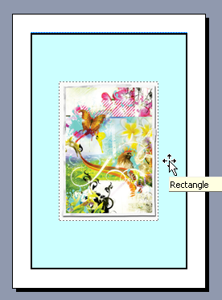
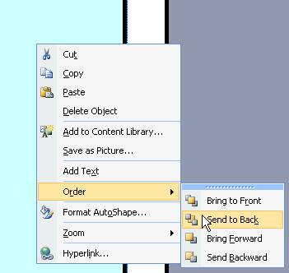
An example of this is shown below.

