Monaghan Institute
QQI 5N0785
Desktop Publishing 5N0785
Aim of the Programme Module: The purpose of this award is to equip the learner with the knowledge, skill and competence to produce a range of documents containing text and graphic images from design briefing to printing, using a Desktop Publishing (DTP) system.
Monaghan Institute
FETAC 5N0785

Learners will be able to generate graphic content using a DTP application to create, import, capture and manipulate images and drawings.

Perform basic editing and transformations on images and drawings to edit, recolour, crop, rescale, rotate and reflect vertically or horizontally.

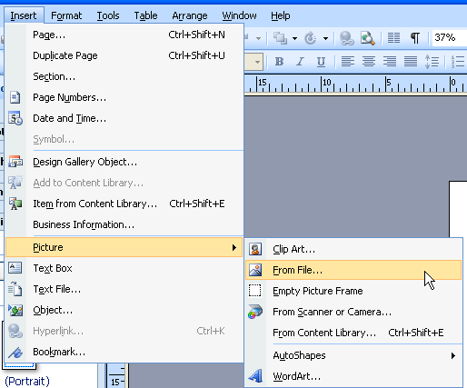
Add an Image or Drawing
When adding an image to a Publisher document there are different locations the image can be taken from. These are Clip Art, a File or from a Scanner or Camera.
The following example shows how to add an image from a file. There are two options for accessing the file. First from Insert > Picture > From File.
The second option is to use the objects toolbox at the left hand side of the screen. Click on the insert pictures icon as shown below.
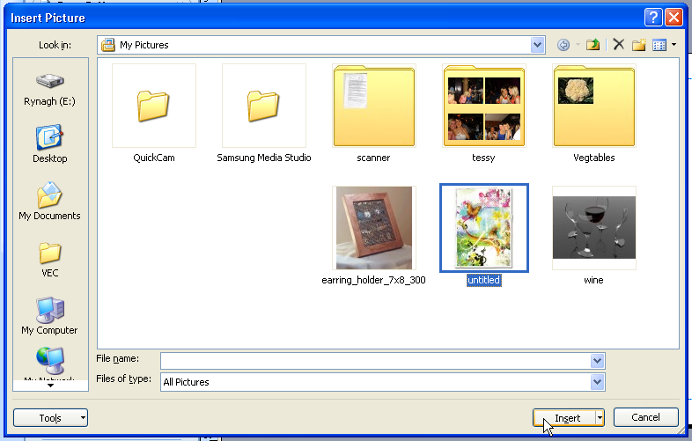

When the Picture From File is selected the Insert Picture window will open. Browse to the location of the file you wish to use, select the file and click on the Insert button.
This will add the select image to the document.
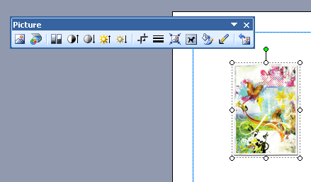

NOTE: When an image or object is selected the Picture Toolbar automatically becomes available for the user. To get rid of the Picture toolbar click away from the image. This also applies to word art, clip art and shapes.

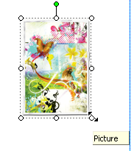
Rescale
To rescale an image means to resize the image. To do this select the image and click on any of the 8 small white circles around the image edge. Click and hold the circle and scale the image size up or down to the desired image size. You will see a frame indicating the size of the image released the image will change to the new size.
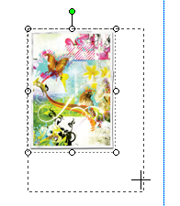
NOTE: To keep the image in the correct proportions it is better to use one of the corner circles, otherwise the image will become distorted.

Crop
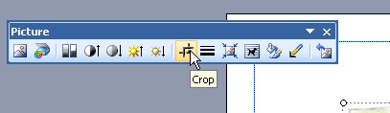
To crop an image means to cut some edging off the image. To use this tool select the picture and select the crop tool from the Picture toolbar as shown.

Cropping symbols are shown on the edges of the image/picture after this option is selected. To crop the image in any particular direction click on the cropping icon with your mouse hold the mouse button down and drag the crop tool to the desired size. Note that cropping can happen from any side or corner of the image and cropping can be undone at any time by dragging out from the image again. The following image has been cropped to only show the butterfly from the original picture.
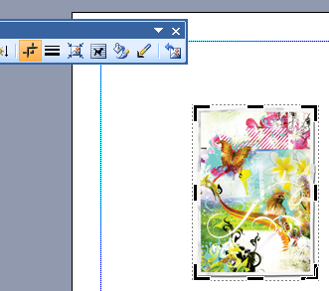

Adjust Brightness or Colour
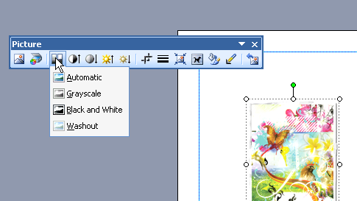
An image can be shaded according to its brightness, darkness and colour scale. Shown below is the Picture toolbar option to change an image to black and white, greyscale or washout.

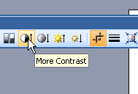

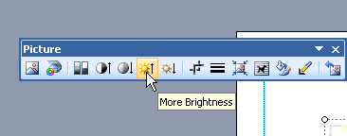
In addition an image can be changed according to its brightness and its contrast.

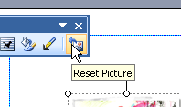
To reset an image to its original format click on the reset picture button (this will also reset cropping).

NOTES:

Construct graphic shapes such as lines, rectangles, ovals and polygons etc. With variations in line-styles and fills.

Construct Lines – Line Styles
Lines can be added to the document by clicking on Connectors and dragging the line to the required length and size.
The different types of lines available are ….
To edit the line style …

Auto Shapes – Rectangles, Ovals and Polygons Line Styles and Fills
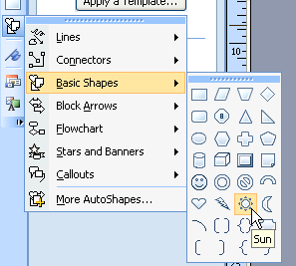
To add auto shapes in Publisher click on the Auto Shapes symbol in the Objects toolbar. Select the symbol required and drag it to the desired size by clicking on the page and dragging the mouse down/out.

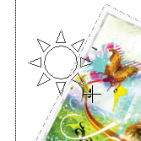
In this example the sun has been added to the document.

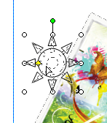
The perspective of the image can be changed by clicking on the yellow diamond on the image and dragging in and out. This can change the thickness of the rays of the sun and the diameter of the centre of the sun.

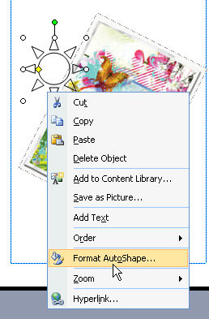
To edit the formatting of the auto shape right click on the shape and select Format AutoShapes. This will allow you to change the colour, shading and line size of the shape. These options can also be edited on Format toolbar.
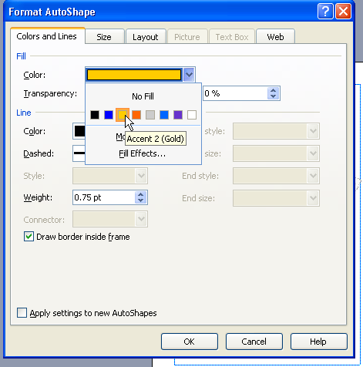

Ordering(Layering)
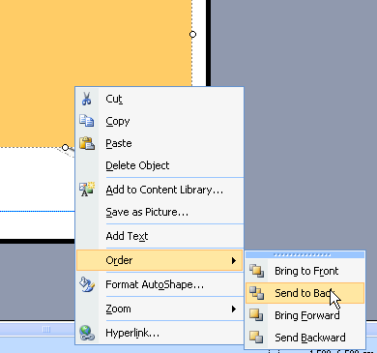
In this example I have added a yellow box to my document. I want to use this as a background for my document. To move this behind the objects that are already on the publisher document I can right click on the box and Order it to be Sent to Back. This will move it behind the other object on the document.
Objects can also be moved up or down one layer at a time.
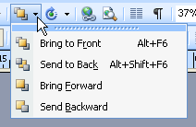
This option can also be accessed from the Standard toolbar.
NOTE: Objects are layered in the document in the order they are created.

Construct Graphics (Grouping Objects)
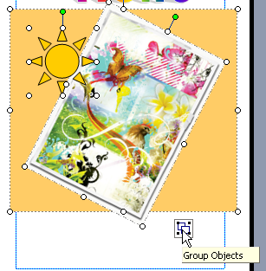
To group objects highlight all required objects by clicking on them. To select more than one object at a time click and hold the Shift key on the key board and select the objects with the mouse. At the bottom right corner of the select a grouping button will appear. To group all the objects as one image click on this button. This will allow you to move and resize all the objects as one object. Grouping can also be accessed by right clicking on the highlighted group of objects.
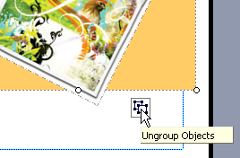
To remove this option click on the ungroup button in the bottom right corner of the group.

Applying Object Alignment
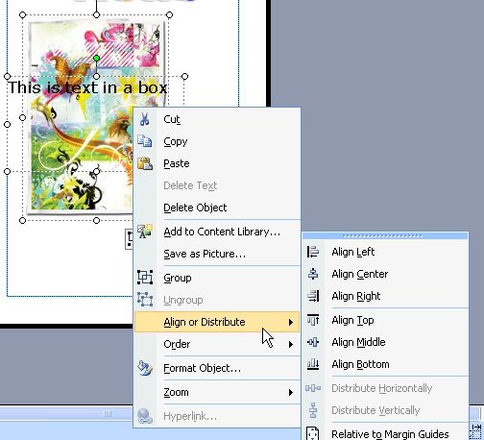
Objects such as word art, text boxes, images and auto shapes can be aligned according to each other. To access this option it is important to select more than one object by holding the shift key and clicking on the two required objects.
Right click on the objects and Align or Distribute the objects as you require. In the example shown the objects have been aligned to the Centre.

Add word art and auto shapes
To add work art to a publisher document click on the word art tool on the objects toolbar.
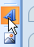
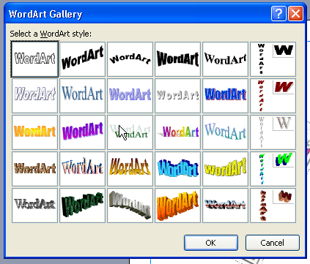
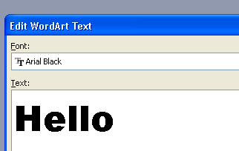
Select the style of word art you wish to use and select OK. Enter the words or text you wish to add, choose the font style and size, and click on ok. Word art can be resized as any other auto shape or image would be edited. To change the text double click on the text and the text window will be reopened.

Rotate an Image
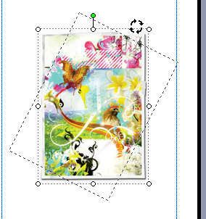
Click on the image and click on the rotation symbol at the top of the picture (green circle). Click and drag the image to its new rotation position and release the mouse button.
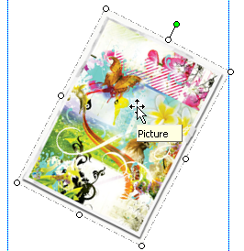

Move an Image
To move an image click on the image, hover over the image until the curser appears as four pointing arrows as shown. This is the movement tool. Click and drag the image to the required location.

Perform basic editing of and transformations of graphic images e.g. to recolour, copy, pixel-edit, rescale, reflect, rotate etc.

Reflect or Inverse
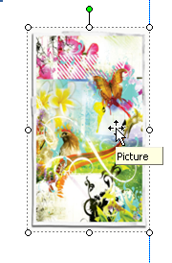
To invert an image means to flip it over itself. To invert any image or shape in Publisher click on the top or side circles which appear when you click on the image. In the example below I have clicked on the left circle and pushed the curser across the front of the image. This flips the image straight over itself and the image appears overturned or reversed.
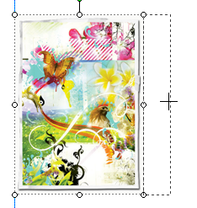

Scanning/importing and saving graphics in a format compatible with DTP software.

