Desktop Publishing 5N0785
Learning Outcome 3
Monaghan Institute Level 5 Module

Contents

1. Apply typography tools to specify features such as fonts, sizes, styles, spacing, placement, orientation, colour, alignment, indentation and page layout . 1
What is typography? 1
Formatting Features Available 1
2. Distinguish between bit-map and vector images. 6
Image resolution? 6
3. Distinguish between different graphic file types such as JPEG, GIF, TIFF, BMP, PSD, etc. 6
Additional Resources 7
Revision Questions 7

Learners will be able to outline the essential considerations for handling text and graphics in DTP documents including size, resolution, format, placement, orientation and colour, in the context of a range of page layouts.

Apply typography tools to specify features such as fonts, sizes, styles, spacing, placement, orientation, colour, alignment, indentation and page layout .

What is typography?
Typography is the art and technique of arranging type in order to make language visible. The arrangement of type involves the selection of typefaces, point size, line length, leading (line spacing), adjusting the spaces between groups of letters (tracking) and adjusting the space between pairs of letters (kerning). Typography is performed by typesetters, compositors, typographers, graphic designers, art directors, comic book artists, graffiti artists, clerical workers, and anyone else who arranges type for a product.
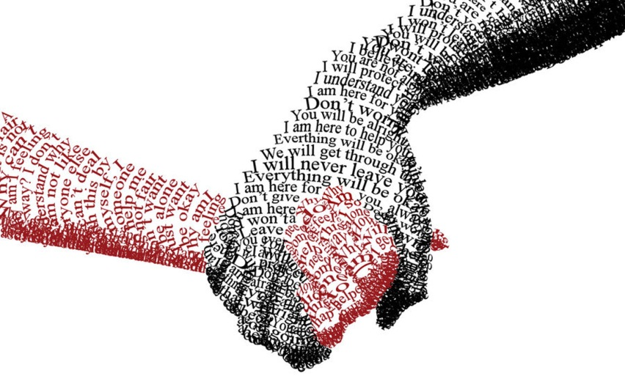
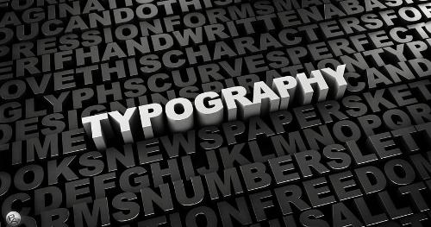

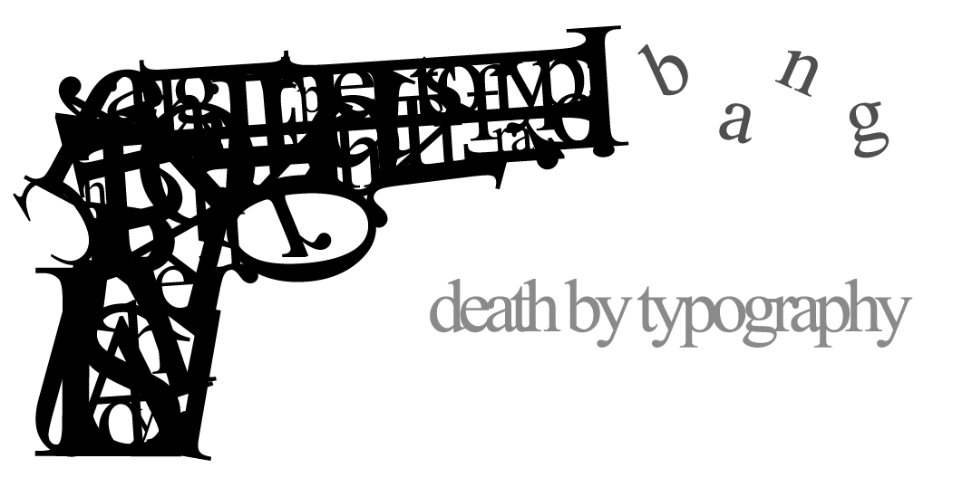

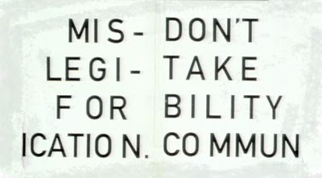
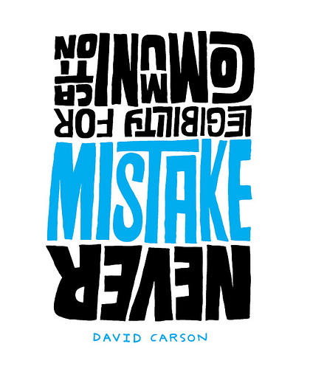

Formatting Features Available
The toolbar at the top of any Microsoft software is known as the ribbon, along the ribbon there are a series of tabs in Microsoft Publisher for example Home, Insert and Page Design. On each of these tabs are command buttons which allow different options for example change formatting, alignment, insert text boxes, adjust line spacing and add columns. These commands are shown in groups. In this image the Home tab and the Clipboard, Font and Paragraph groups can be seen.
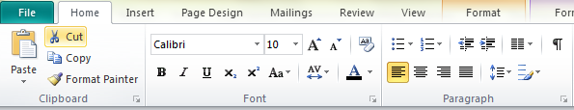
To see the name of a command and understand what that command does hover over the button symbol or text (without clicking) for just over a second. This will show the command name, an explanation of what that command does and it’s short cut key is shown (not all commands have shortcut keys). In the example shown the mouse was over the Character Spacing command therefore the name and explanation are shown.

This example shows the Increase Font Size command button its name, an explanation and its associated shortcut keys.
- Take time to familiarise yourself with as many commands as you can, start with the Home tab and ensure you understand how all of these commands work before the end of this class.
Note: There are different ways of using commands, including keyboard shortcuts and accessing the same command on a variety of different menus. The following commands are shown using one method but there is usually more than one way to use commands.

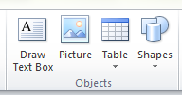
Text Box
In Microsoft Publisher all text sits inside text boxes, to add a text box go to the Home tab and to the Objects group and select Draw Text Box. Then click on the page and draw the size of the text box required in the correct location.

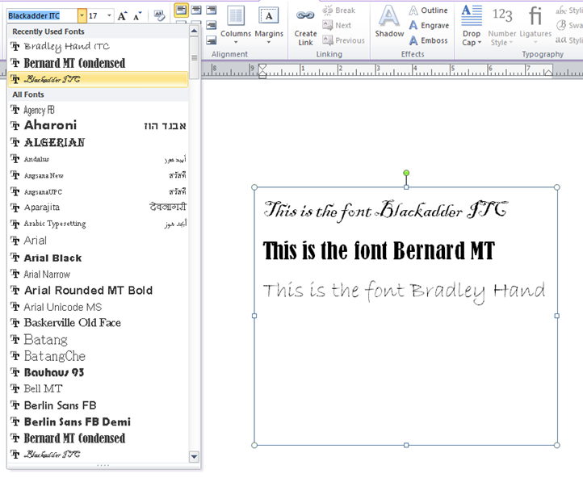
Font Face
A font face is the style of writing being used. To change the font face highlight the text and the Text Box Tools menu will appear. On this menu in the Font group the font face list can be accessed and a new font can be selected.
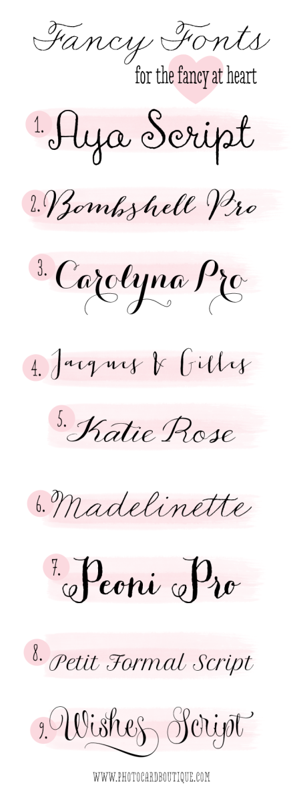
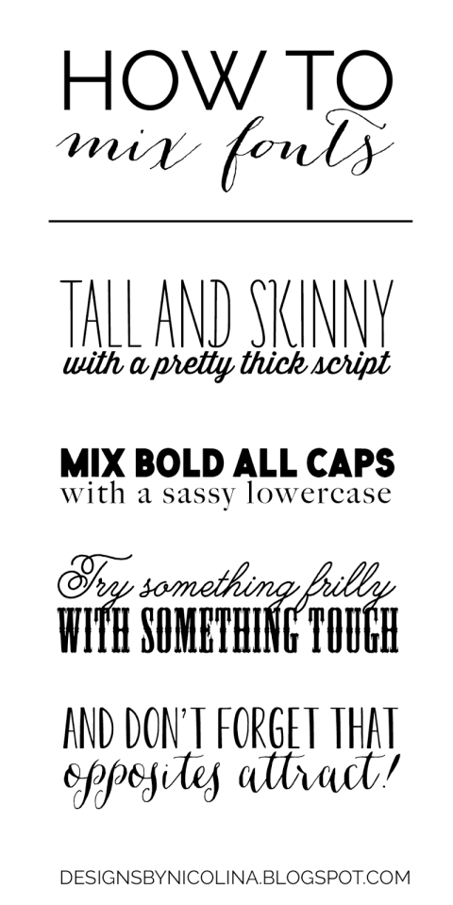

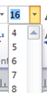
Size
Font size can be increased and decreased. To change font size highlight the font and click on the font size drop down menu. In addition the Increase Font Size and Decrease Font Size buttons can be used.
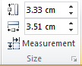
Shape Size - consider also the size of shapes and text boxes, on the Drawing Tools Format tab there is a group called Size, experiment with the Measurement button to see what information is shown.

Style
Styles are pre-set designs which can be applied to text or to shapes. To apply text styles highlight the text and use the Styles drop down menu on the Home tab in the Styles group. From this menu it is possible to create new styles.
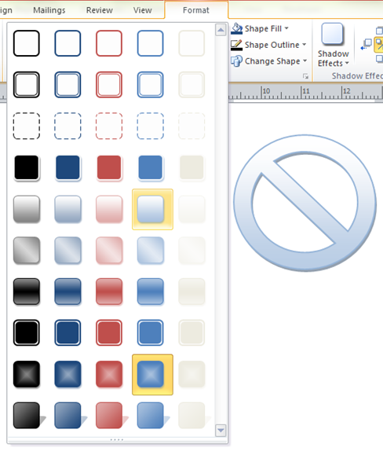
To apply shape styles insert the required shape and click on it. The Format Drawing Tools menu will appear and a shape style can be applied from the Shape Styles group as shown.
Notes:

Spacing
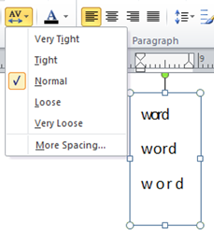
Spacing is applied to text in a variety of different ways. The following are the three main options:
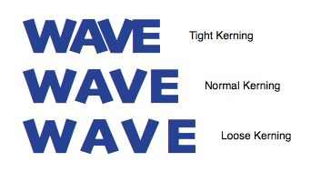
Characters in Words - this is known as kerning which means to adjust the spacing between two letters in a word. This is applied using the Character Spacing command and can be used to keep letters close together or to spread them far apart.

Lines - line spacing dictates how close the lines in a paragraph are to each other. Text is normally at around 1.5 spacing. To change the line spacing options go to the Home tab to the Paragraph group and click on the Line Spacing button as shown. In the image shown the line spacing has been changed to 1.0 so the lines of text sit close together.
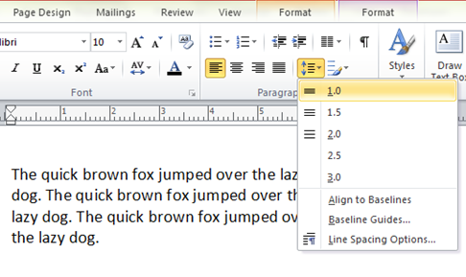

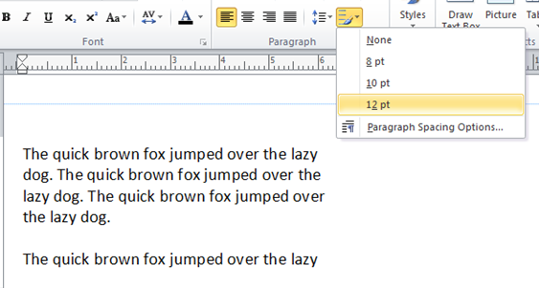
Paragraphs - before and after each paragraph there is a space. This can be increased or decreased using the Paragraph Spacing button. This can be found in the Home tab on the Paragraph group.

Placement
The placement position of text boxes and graphics or shapes in Publisher is decided by the user, to position any object click on the object and using the movement tool drag to the desired location. Objects in Publisher are layered on top of each other or sit next to each other depending on their position or the wrapping applied to them.

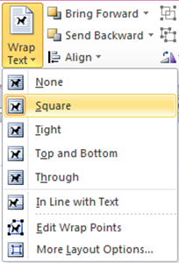
Wrapping
The wrapping of an object dictates how it behaves in relation to the objects next to it, the wrapping options are as shown here. To access the wrapping command click on the object and the Picture Tools tab will appear, the Wrap Text command is in the Arrange group. The most commonly used wrap options are None and Square experiment with these options.

Orientation

Colour

Alignment

Indent

Page Layout

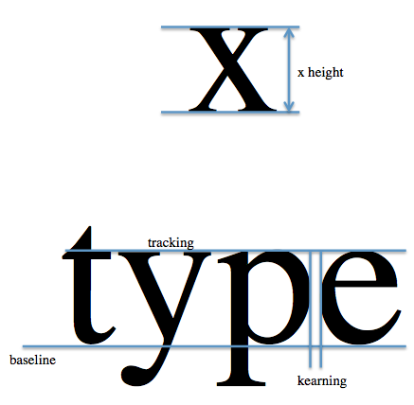

Distinguish between bit-map and vector images.

Image resolution?

Distinguish between different graphic file types such as JPEG, GIF, TIFF, BMP, PSD, etc.

Notes:

Additional Resources

Websites:

Revision Questions

- Explain what is meant by

