Question 1 Filtering

- All except Blue and Black.
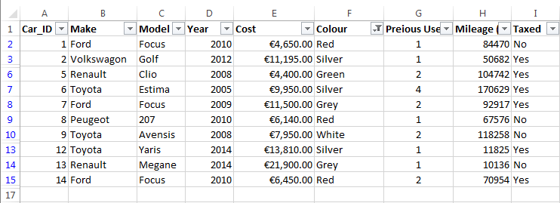

- Cars after 2010.
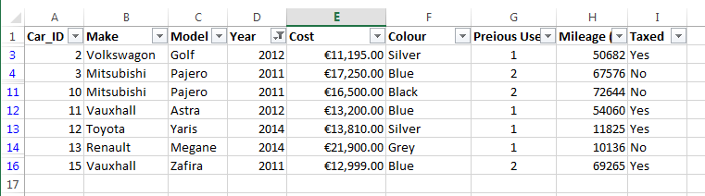

Question 2 Customise Toolbars
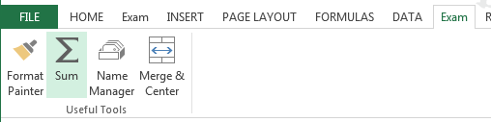

Question 3 Importing Data and Creating Hyperlinks

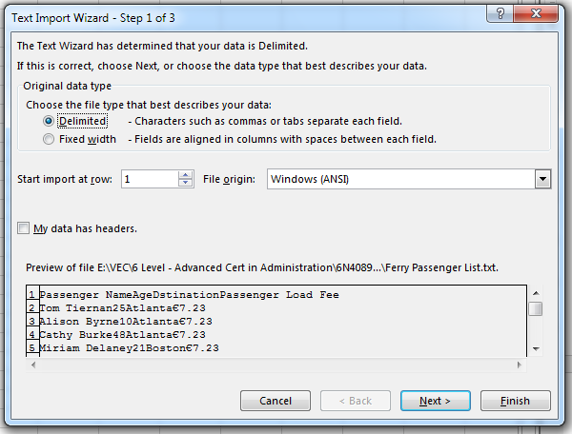

Question 4 Freezing Panels and Show/Hide Rows or Columns
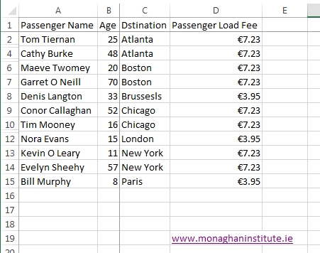

Question 5 Evaluate Formula and Trace Precedents/Dependents

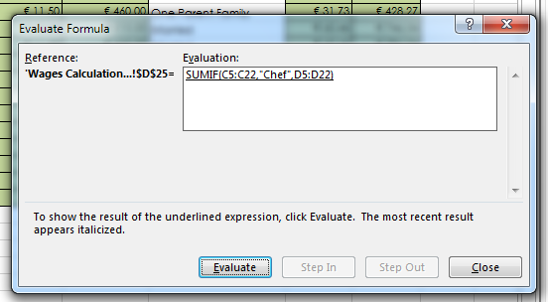

Question 6 Worksheet and Cell Protection

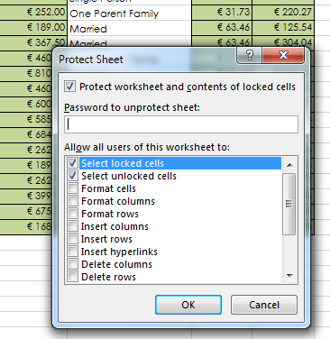

Question 7 Pivot Tables

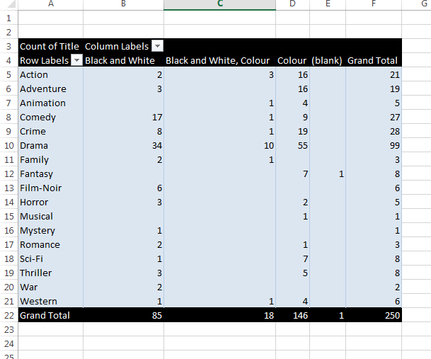

Question 8 Data Validation
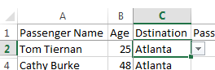

Question 9 Conditional Formatting

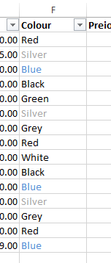

Question 10 Critique Spreadsheet Design
2 Changes.

